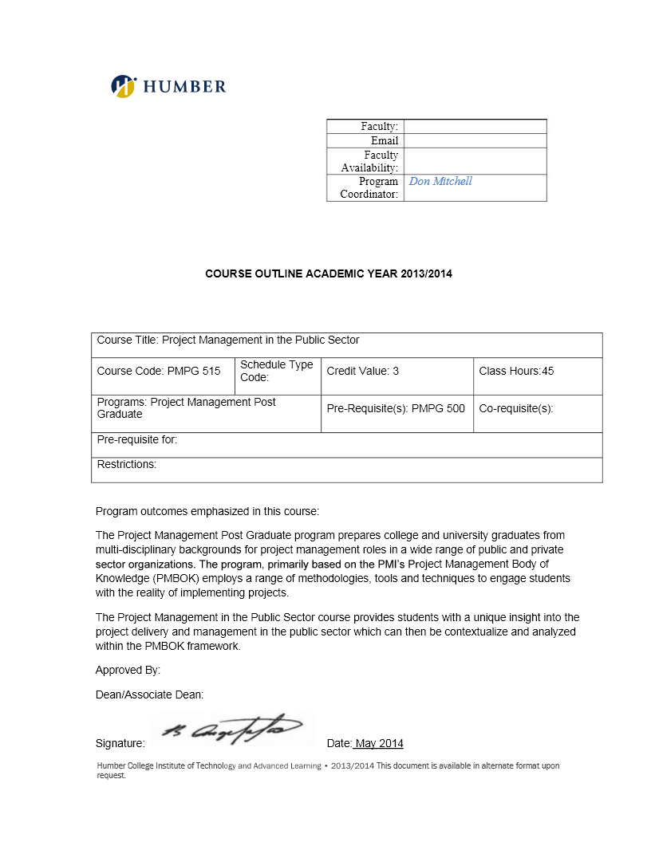

**BUS 5003  
Project Management Assignment:**

**Project Proposal**

***Professor: Nadine Blaides***

**Group #**: Trailblazers

**Team Members (alphabetical by last name):**

1. Ladan Asempour
2. Alexandra Gladkova
3. Kushwanth Sai Kolli
4. Hao Lun Rong
5. Christina Saju

**Submission Date**: 2/1/2025

| Project Proposal Form | | | | | | | | | | | |
| --- | --- | --- | --- | --- | --- | --- | --- | --- | --- | --- | --- |
| Project Name: | Breaking Barriers in Housing | | | | | | | | | | |
| Project classification: |  | Compliance | |  | Operational | | | **✓** | | Strategic | |
| What business problem does the project solve? | This project aims to analyze how current rent regulations impact housing accessibility in regions with high unemployment. By evaluating requirements like proof of employment and acceptance of government or disability payments for rent, we will identify legislative and programmatic changes to make housing more inclusive and accessible. Our goal is to propose actionable policies that reduce barriers to stable housing, ultimately addressing homelessness in vulnerable communities. | | | | | | | | | | |
| How will this project address the problem?  *Include rationale / justification and the purpose of the project.* | We will study how current rent rules affect housing and identify where they create barriers. Then, we will recommend changes to make these rules fairer and more inclusive. This will help more people access stable housing and reduce homelessness. | | | | | | | | | | |
| How does this project align with the organizational strategy? | We are aiming to reduce systemic barriers and promote inclusivity by addressing housing accessibility issues. This project supports our strategic goal of making a positive social impact and creating equitable housing opportunities for all. | | | | | | | | | | |
| What are the major objectives of the project?  *Please present them as SMART objectives – should include 5* | 1. Conduct a comprehensive analysis of rent regulations in three regions with high unemployment by March 31, 2025, to identify specific barriers to housing accessibility. 2. Develop a report with three actionable policy recommendations to improve housing accessibility and deliver it to stakeholders by May 31, 2025. 3. Host two stakeholder workshops by June 30, 2025, to gather feedback on proposed policies and ensure inclusivity in the recommendations. 4. Publish one public report summarizing findings and policy recommendations by July 31, 2025, to increase awareness of housing accessibility challenges. 5. Measure the impact of implemented policy recommendations and achieve a 10% reduction in housing accessibility barriers in targeted regions by December 31, 2025. | | | | | | | | | | |
| What is the impact of not doing the project? | Vulnerable groups in areas with high unemployment will keep struggling to find housing, homelessness will rise, and policymakers won’t have the data they need to fix the problem. | | | | | | | | | | |
| What are four major risks for this project?  *Please provide an If / Then statement for each – e.g. If X event occurs Then y is the consequence to the project.* | Risk | | | | | | | | Probability | | Impact |
| If there is resistance from policymakers to change the regulations,  Then the proposed reforms may not be adopted, and the project will fail to achieve its goals. | | | | | | | | High | | High |
| If external funding or resources are delayed,  Then the project timeline and deliverables will be impacted. | | | | | | | | Medium | | High |
| If the research data is incomplete or unreliable,  Then the project findings will be skewed, reducing the effectiveness of the proposed solutions. | | | | | | | | Medium | | High |
| If key stakeholders do not participate in workshops or provide feedback,  Then policy recommendations may lack inclusivity. | | | | | | | | Medium | | Medium |
| How will we measure success?  *What will be different at the end of the project?* | 1. We will measure success by completing a detailed report with clear recommendations to make housing more accessible. 2. Success will also depend on whether policymakers and advocacy groups accept and start using our recommendations. 3. We will look at real changes in housing accessibility through surveys or case studies after the project is done. | | | | | | | | | | |
| Will the project require internal resources? | **✓** | | Yes | | |  | No | | | | |
| Will the project require external resources? | ✓ | | Yes | | |  | No | | | | |
| What is the estimated cost of the project? | Total estimated cost: $200,000  Research and Data Collection: $50,000  Solution Development: $40,000  Stakeholder Engagement: $30,000  Implementation Planning: $40,000  Monitoring and Evaluation: $20,000  Contingency: $20,000 | | | | | | | | | | |
| How long will the project take?  *Include a brief timeline for the entire project (quarters or months), and sequence the objectives listed above (which comes first, second, etc.).* | The project will take approximately 12 months to complete  Q1: Conduct research and collect data  Q2: Conduct data analysis, compile a report, derive insights and develop policy recommendations  Q3: Host meetings with stakeholders and finalize the policy recommendations  Q4: Publish report, implement changes and conduct surveys to measure initial changes | | | | | | | | | | |

Please answer the following questions in paragraph format to apply the learnings from class to your project proposal.

1. What evaluation criteria do you recommend for this type of project? Create a weighted scoring table with at least four financial or non-financial criteria to evaluate this type of project.

|  |  |  |  |  |  |
| --- | --- | --- | --- | --- | --- |
| **Criteria ->** | **Social Impact** | **Cost** | **Sustainability** | **Stakeholder Involvement** | **Weighted Total** |
| **Weights ->** | 4.0 | 3.5 | 3.0 | 1.0 |  |
| Breaking Barriers in Housing | 8 | 7 | 6 | 4 | **78.5** |
| Senior Care | 7 | 6.5 | 4 | 5 | 67.75 |

1. What type of project management structure do you anticipate in the organization? Provide two examples to demonstrate why you selected that structure, and identify three strategies for how you will leverage the advantages, and/or manage the disadvantages related to the project management structure you selected (can be bullet points).

**Matrix Structure**

This project will require various teams working together under collaborative supervision.

Matrix structure will allow the teams to work in tandem while completing separate tasks within their competency, such as data analysis, research, policy development, stakeholder connections, etc.

Matrix structure will also allow more flexibility within resource allocation following the changes that need to be made as the project progresses and evolves.

Strategies:

1. Management will focus on monitoring workload to avoid burnout by distributing tasks and ensuring realistic timelines for each team.
2. Provide adequate training for team members to ensure full understanding of the matrix structure, such as whom to report to with certain activities and where and when to seek guidance.
3. Establish cross-functional collaboration by hosting regular “all hands on deck” meetings to ensure alignment on overall project goals and progress and collecting feedback from team members and management.